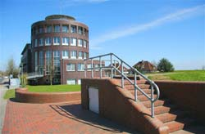
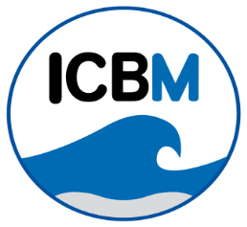
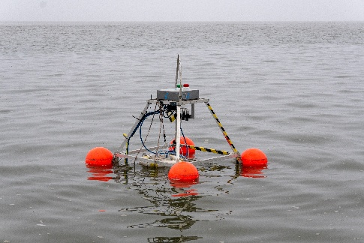

Bachelor's/Master's thesis or practical course (Kontaktpraktikum) at ICBM!
Flexible start date and workplace.
Topic: Gas Transfer Velocities and Turbulence
The ICBM working group "Processes and Sensing of Marine Interfaces" offers the opportunity to undertake a bachelor's or master's thesis in a coastal oceanography project with Matthias Koschorreck from Helmholtz-Zentrum für Umweltforschung (UFZ). There is a chance to complete a contact internship beforehand. A better understanding of the turbulence effects in air-sea gas exchange is necessary to enhance climate models. We propose measuring air-sea gas fluxes alongside oceanic turbulence. We will use two buoys to measure air-sea gas fluxes, an Acoustic Doppler Current Profiler and an Acoustic Doppler Velocimeter attached to the buoy. You can conduct field sampling in Jade Bay or a drinking water reservoir and gain hands-on experience preparing and maintaining ocean technology. This work could produce a quality paper, especially for a master's thesis.
You should have:
- • A passion for fieldwork
- • A strong interest in multidisciplinary research
- • Confidence in communicating in English
We offer:
- • Experience operating the Sniffle (an autonomous drifting buoy for measuring air-sea CO₂ fluxes).
- • Data processing using Python and/or Matlab® along with big data management.
- • A pleasant working environment in an interdisciplinary and international team.

Please send your application, questions, or other project interests to Mariana Ribas Ribas (mariana.ribas.ribas@uol.de)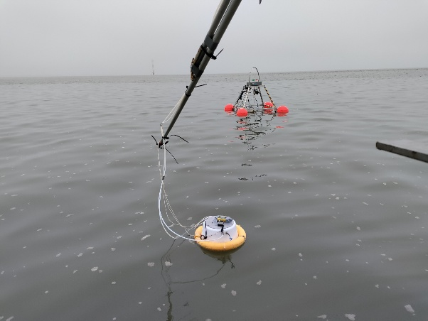 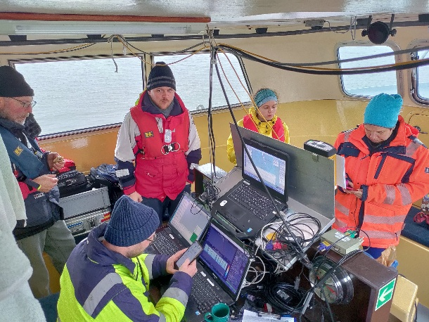
Photos from a cruise with the team in Jade Bay aboard the RV Otzum in November 2024 (credits: Patrick Aurich).

